
LAB ASSIGNMENT 1
WRDA YOUSAF
SP23-BSE-042
TRANPORT MANAGEMENT SYTEM
USECASE LOGIN

CODE
<!DOCTYPE html>
<html lang="en">
<head>
<meta charset="UTF-8" />
<meta name="viewport" content="width=device-width, initial-scale=1.0"/>
<title>Login Screen</title>
<style>
body {
display: flex;
height: 100vh;
align-items: center;
justify-content: center;
font-family: Arial, sans-serif;
background: #f0f2f5;
}
.login-container {
background: white;
padding: 2rem;
border-radius: 8px;
box-shadow: 0 0 10px rgba(0,0,0,0.1);
width: 320px;
}
.login-container h2 {
margin-bottom: 1rem;
text-align: center;
}
.login-container label {
display: block;
margin-top: 0.75rem;
}
.login-container input {
width: 100%;
padding: 0.5rem;
margin-top: 0.25rem;
border: 1px solid #ccc;
border-radius: 4px;
}
.login-container button {
width: 100%;
padding: 0.75rem;
margin-top: 1.25rem;
border: none;
background: #007bff;
color: white;
font-size: 1rem;
border-radius: 4px;
cursor: pointer;
}
.login-container .error {
margin-top: 1rem;
color: #d00;
text-align: center;
}
</style>
</head>
<body>

<div class="login-container">
<h2>Login</h2>
<form id="loginForm">
<label for="email">User ID (email)</label>
<input type="email" id="email" required />

<label for="password">Password</label>
<input type="password" id="password" required />

<button type="submit">Sign In</button>
</form>
<div class="error" id="errorMsg"></div>
</div>

<script>

class User {
constructor(id, password) {
this.id = id;
this.password = password;
}
}

class UserValidator {
static isValidUID(user, email) {
return user.id === email;
}
static isValidPass(user, password) {
return user.password === password;
}
}

class UserRepository {
constructor() {
this.users = [];
}
addUser(user) {
this.users.push(user);
}
findUserByEmail(email) {
return this.users.find(u => u.id === email);
}
}

class DBManager {
static getConnection() {
console.log("Database connected.");
}
static checkUser(repo, email) {
return repo.findUserByEmail(email);
}
}

class UserController {
constructor(repo) {
this.repo = repo;
}
authenticate(email, password) {
const user = DBManager.checkUser(this.repo, email);
if (!user) {
return { success: false, message: "User not found." };
}
if (!UserValidator.isValidPass(user, password)) {
return { success: false, message: "Invalid password." };
}
return { success: true, message: "Login successful!" };
}
}

const userRepo = new UserRepository();

userRepo.addUser(new User("user@example.com", "password123"));
DBManager.getConnection();
const userCtrl = new UserController(userRepo);

const form = document.getElementById("loginForm");
const errorDiv = document.getElementById("errorMsg");

form.addEventListener("submit", e => {
e.preventDefault();
errorDiv.textContent = "";

const email = document.getElementById("email").value.trim();
const password = document.getElementById("password").value;

const result = userCtrl.authenticate(email, password);

if (result.success) {
errorDiv.style.color = "green";
} else {
errorDiv.style.color = "#d00";
}
errorDiv.textContent = result.message;
});
</script>
</body>
</html>

PROTOTYPE
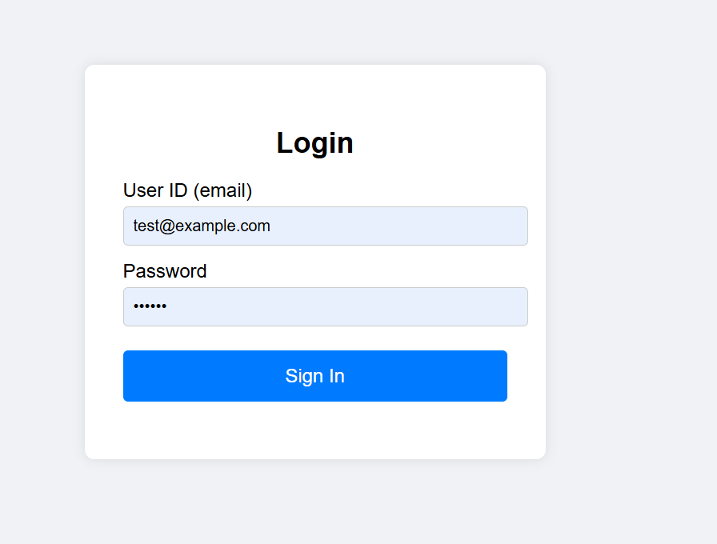

DATBASE
CREATE DATABASE login_system;
USE login_system;
CREATE TABLE users (
user_id VARCHAR(50) NOT NULL PRIMARY KEY,
password VARCHAR(255) NOT NULL
);
INSERT INTO users (user_id, password)
VALUES ('warda123', '12345');
SELECT * FROM users WHERE user_id = 'warda456' AND password = 'mypassword123';

